# Instructions for setting up storage and notebook instance in your personal AWS account

1. Login to AWS account using the link below <https://systechusa.signin.aws.amazon.com/console>
2. Go to S3 and create a new bucket <bucket_name> and then create a folder under it by the name ‘PROPENSITY-DATA’ and upload the file from the GitHub repository
3. Open and access the SageMaker console by searching Amazon SageMaker in the **Find Services** search bar

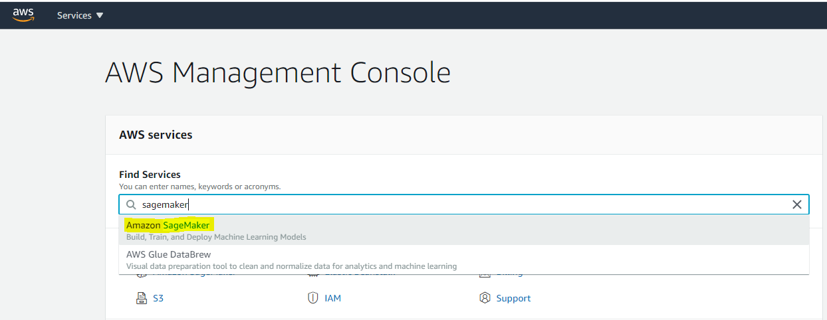

1. You should be able to see the SageMaker console as shown below

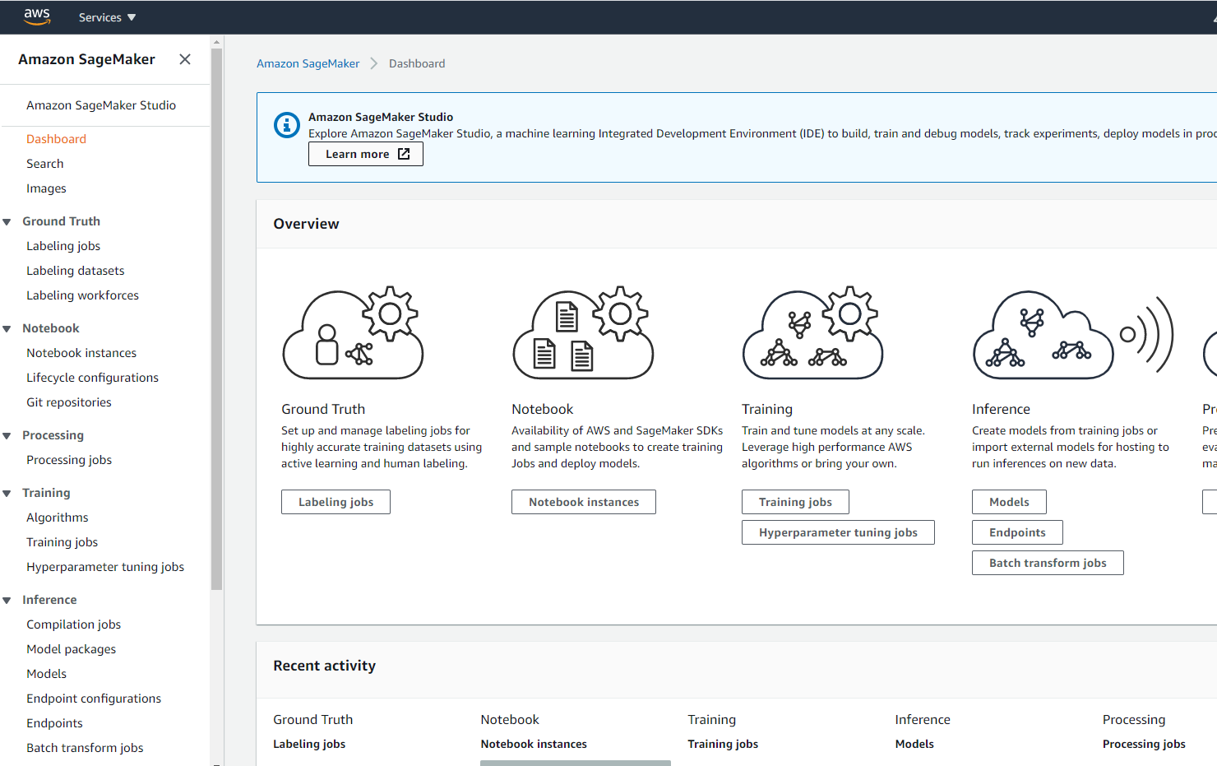

1. In the Amazon SageMaker console, Choose **Notebook instances**, then create a new notebook instances with Instance type as ml.t2.medium. As soon as the notebook instance is InSerivce, click on Open Jupyer
2. In the Jupyter console click on upload and select the script file aviable in the repositoy “”
3. Once you open the script

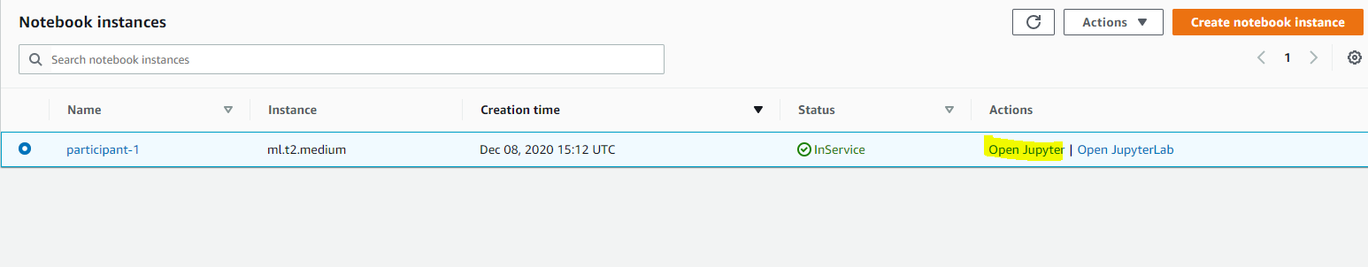

1. Inside the Jupyter console, you should be able to see a script by the name **Training_solicitation_email_welcome.ipynb.** Click on it and you will be redirected to the script console

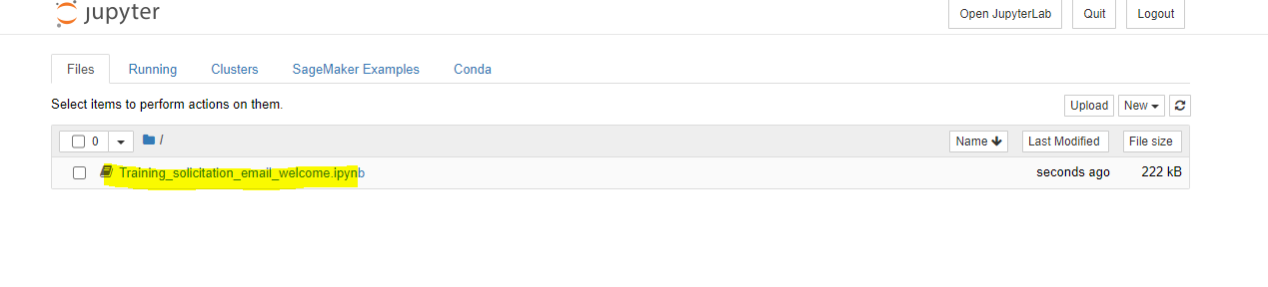

1. In the cell under the text ‘**Read data from S3**’

Change the bucket name to the name that you specified in step 2:

(**<bucket_name>** )

Change the prefix to :

**PROPENSITY-DATA/xgboost/training-files**

Change the data_location to:

**PROPENSITY-DATA /simulated_email_data_lab.csv**

